**Harvest Insights: Unveiling Global Food Production Trends and Analysis From 1961 to 2023 with Power BI**

**Introduction :**

This project aims to analyze global food production trends from 1961 to 2023 using Power BI. By leveraging data visualization techniques, the project provides insights into the production patterns of key agricultural commodities such as wheat, rice, maize, and fruits. The analysis enables stakeholders to understand long-term trends, identify production growth regions, and optimize agricultural strategies for food security and sustainability. Through an in-depth examination of production volumes, regional contributions, and yearly growth patterns, stakeholders can make informed decisions to enhance agricultural productivity and resource allocation. Ultimately, the goal is to empower decision-makers with data-driven insights for strategic planning in the global agricultural sector.

**Scenario 1 - Monitoring Global Crop Production Trends:**Governments and agricultural organizations need to track the production of staple crops over time. By using **"Harvest Insights: Illuminating Global Food Production Trends"** with Power BI, they can analyze historical production data for wheat, maize, and rice. Interactive dashboards help visualize trends in different regions, identify production peaks, and assess the impact of climate change on crop yields. This enables policymakers to develop sustainable agricultural strategies and ensure food security worldwide.

**Scenario 2 - Regional Analysis of Commodity Production:**Food industry stakeholders want to identify leading producers of agricultural commodities like fruits, tea, and coffee. With **"Harvest Insights"**, they can analyze the total production of apples, bananas, oranges, and grapes across different regions. Power BI's visualization capabilities allow them to compare production across continents, determine market trends, and forecast future demand. This helps businesses optimize supply chains, manage imports and exports, and make data-driven investment decisions in the food sector.

**Scenario 3 - Understanding Growth Trends in Staple Crop Production:**Researchers and economists seek to analyze how staple crop production has evolved over decades. Using **"Harvest Insights"**, they can track the increase in wheat, maize, and rice production from 1961 to 2023. Power BI’s analytical tools allow them to visualize yearly production growth, detect patterns in agricultural output, and evaluate the impact of technological advancements in farming. These insights enable stakeholders to implement policies that promote agricultural innovation and ensure sustainable food production for the future.

**Technical Architecture:**

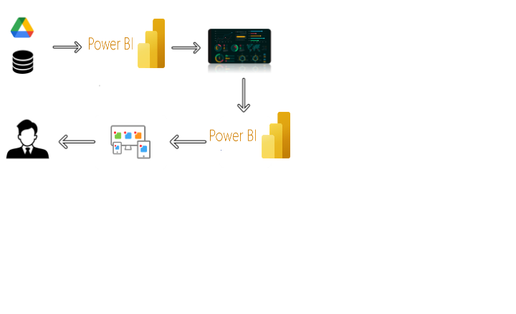

**Project Flow**

To accomplish this, we have to complete all the activities listed below,

* Data Collection & Extraction from Database
  + Collect the dataset,
  + Storing Data in DB
  + Perform SQL Operations
  + Connect DB with Power Bi
* Data Preparation
  + Prepare the Data for Visualization
* Data Visualizations
  + No of Unique Visualizations
* Dashboard
  + Responsive and Design of Dashboard
* Report
  + Responsive and Design of Dashboard
* Performance Testing
  + No of Visualizations/ Graphs
* Project Demonstration & Documentation
  + Record explanation Video for project end to end solution
  + Project Documentation-Step by step project development procedure

**Milestone 1: Data Collection & Extraction from Database**

Data collection is the process of gathering and measuring information on variables of interest, in an established systematic fashion that enables one to answer stated research questions, test hypotheses, and evaluate outcomes and generate insights from the data.

**Activity 1: Collect the dataset**

Please use the link to download the dataset: [Link](https://www.kaggle.com/datasets/rafsunahmad/world-food-production)

**Activity 1.1: Understand the data**

The dataset contains meta-information regarding global food production trends from 1961 to 2023. It includes various agricultural commodities and their yearly production across different regions. We have provided **5 CSV files**, each containing specific details about food production.

**Column Descriptions:**

**Entity** – The country or region where food production is recorded.

**Year** – The year in which the production data was collected (1961–2023).

**Maize Production (tonnes)** – Total maize (corn) production in tonnes for a given year and entity.

**Rice Production (tonnes)** – Total rice production measured in tonnes.

**Yams Production (tonnes)** – Production of yams in tonnes per year.

**Wheat Production (tonnes)** – Total wheat production across entities and years.

**Tomatoes Production (tonnes)** – Yearly production of tomatoes by country or region.

**Tea Production (tonnes)** – The total amount of tea produced in a given year.

**Sweet Potatoes Production (tonnes)** – Annual sweet potato production recorded by region.

**Sunflower Seed Production (tonnes)** – Total production of sunflower seeds per year.

**Sugar Cane Production (tonnes)** – Production volume of sugar cane in tonnes.

**Soybeans Production (tonnes)** – The total yield of soybeans per year.

**Rye Production (tonnes)** – Annual production of rye across entities.

**Potatoes Production (tonnes)** – Yearly production data for potatoes.

**Oranges Production (tonnes)** – The quantity of oranges harvested each year.

**Peas, Dry Production (tonnes)** – Dry peas production data recorded per year.

**Palm Oil Production (tonnes)** – Total palm oil production per entity.

**Grapes Production (tonnes)** – Annual grape production in tonnes.

**Coffee, Green Production (tonnes)** – The amount of green coffee beans produced yearly.

**Cocoa Beans Production (tonnes)** – Production volume of cocoa beans per year.

**Meat, Chicken Production (tonnes)** – Total chicken meat production measured in tonnes.

**Bananas Production (tonnes)** – Yearly banana production across different regions.

**Avocados Production (tonnes)** – Annual avocado production in tonnes.

**Apples Production (tonnes)** – Total apple production recorded per year.

**Activity 2: Connect Data with Power BI**

With Power BI, users can seamlessly connect to a wide range of data sources, including databases, cloud services, spreadsheets, and streaming data. This capability allows organizations to consolidate disparate data sources into a single, unified platform, breaking down data silos and enabling holistic analysis.

Explanation video link:

<https://drive.google.com/file/d/1L4he9T0abxs5cZCtnJUH7bbbUfnXEyDt/view?usp=sharing>

**Milestone 2: Data Preparation**

Data preparation is a critical phase in the data lifecycle, encompassing activities that transform raw data into a format suitable for analysis. This multifaceted process involves several steps including data cleaning, integration, transformation, and enrichment. Data cleaning involves identifying and rectifying errors, inconsistencies, and missing values within datasets to ensure accuracy and reliability.

**Activity 1: Prepare the Data for Visualization**

Preparing the data for visualization involves cleaning the data to remove irrelevant or missing data, transforming the data into a format that can be easily visualized, exploring the data to identify patterns and trends, filtering the data to focus on specific subsets of data, preparing the data for visualization software, and ensuring the data is accurate and complete. This process helps to make the data easily understandable and ready for creating visualizations to gain insights into the performance and efficiency.

**Explanation video link 1:**

<https://drive.google.com/file/d/1LDDVewmsArzawOS7AT_FQQtHhINlkBfY/view?usp=sharing>

**Milestone 3: Data Visualization**

Data visualization is the process of creating graphical representations of data to help people understand and explore the information. The goal of data visualization is to make complex data sets more accessible, intuitive, and easier to interpret. By using visual elements such as charts, graphs, and maps, data visualizations can help people quickly identify patterns, trends, and outliers in the data.

**Activity 1: No of Unique Visualizations**

The number of unique visualizations that can be created with a given dataset depends on the type of analysis required. Some common types of visualizations that can be used to analyze the performance and efficiency of "Harvest Insights: Illuminating Global Food Production Trends" include Barcharts, and Cards, Donut Charts,Area Charts,Ribbon Charts, Funnel, Line Charts…etc,.

**Activity 1.1:** **Sum Of Rice Production**

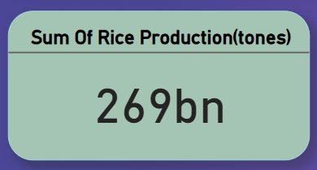

**Activity 1.2:Sum of Wheat Production**

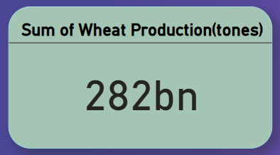

**Activity 1.3:Sum of Tea Production**

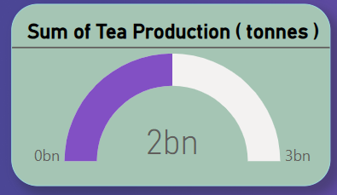

**Activity 1.4: Sum Of Coffee, Green Production**

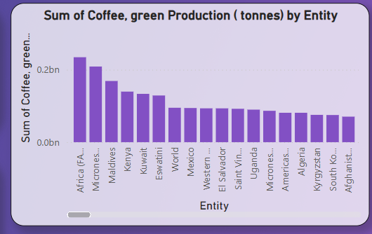

**Activity 1.5: Sum of Wheat Production (tonnes), Sum of Maize Production (tonnes) and Sum of Rice Production ( tonnes) by Year**

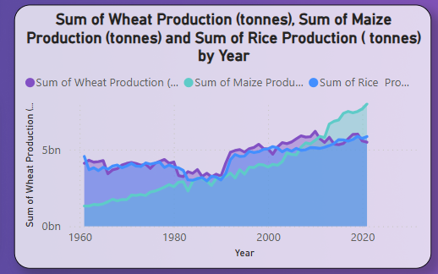

**Activity 1.6: Sum of Apples Production , Sum of Avocados Production , Sum of Oranges Production and Sum of Bananas Production by Entity**

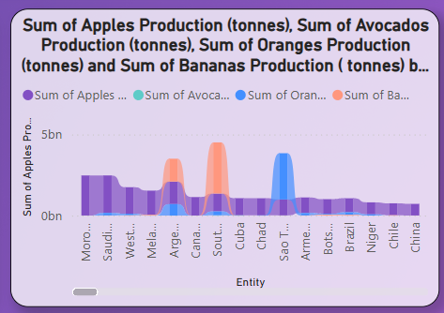

**Activity 1.7: Sum of Maize Production by Year**

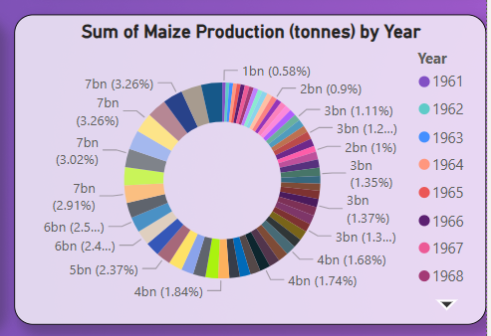

**Activity 1.8:Sum of Grapes Production (tonnes), Sum of Apples Production (tonnes), Sum of Bananas Production ( tonnes) and Sum of Oranges Production (tonnes)**

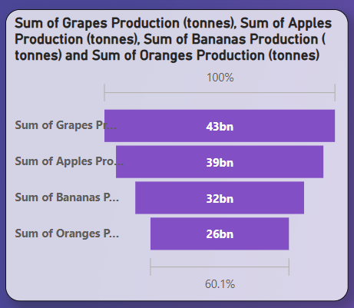

**Milestone 4: Dashboard**

A dashboard is a graphical user interface (GUI) that displays information and data in an organized, easy-to-read format. Dashboards are often used to provide real-time monitoring and analysis of data, and are typically designed for a specific purpose or use case. Dashboards can be used in a variety of settings, such as business, finance, manufacturing, healthcare, and many other industries. They can be used to track key performance indicators (KPIs), monitor performance metrics, and display data in the form of charts, graphs, and tables.

**Activity :1- Responsive and Design of Dashboard**

The responsiveness and design of a dashboard for **"Harvest Insights: Illuminating Global Food Production Trends"** ensures clear, interactive, and data-driven insights into agricultural production. It presents key crop trends concisely, allowing users to filter data by year, region, or crop type. Designed for accessibility across devices, it offers customization for tailored analysis while maintaining data security. This responsive approach enables stakeholders to make informed decisions and optimize agricultural strategies effectively.

Once you have created views on different sheets in Power Bi you can pull them into a dashboard.

Dashboard :

Explanation video link:

<https://drive.google.com/file/d/1fzGzArfhp695UFFUEazJms7kBuGnlsQE/view?usp=sharing>

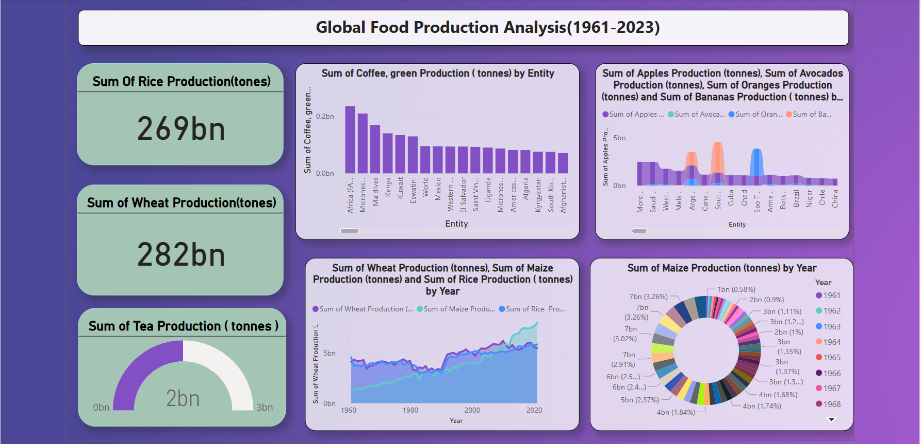

**Milestone 5: Report**

A data report is a way of presenting data and analysis in a narrative format, with the goal of making the information more engaging and easier to understand. A data story typically includes a clear introduction that sets the stage and explains the context for the data, a body that presents the data and analysis in a logical and systematic way, and a conclusion that summarizes the key findings and highlights their implications. Data Report can be told using a variety of mediums, presentations, interactive visualizations, and videos.

**Report :**

**Explanation video link:**

[**https://drive.google.com/file/d/15Jkun-zFQj86YTiYCQoGwznZLURZ2rbQ/view?usp=sharing**](https://drive.google.com/file/d/15Jkun-zFQj86YTiYCQoGwznZLURZ2rbQ/view?usp=sharing)

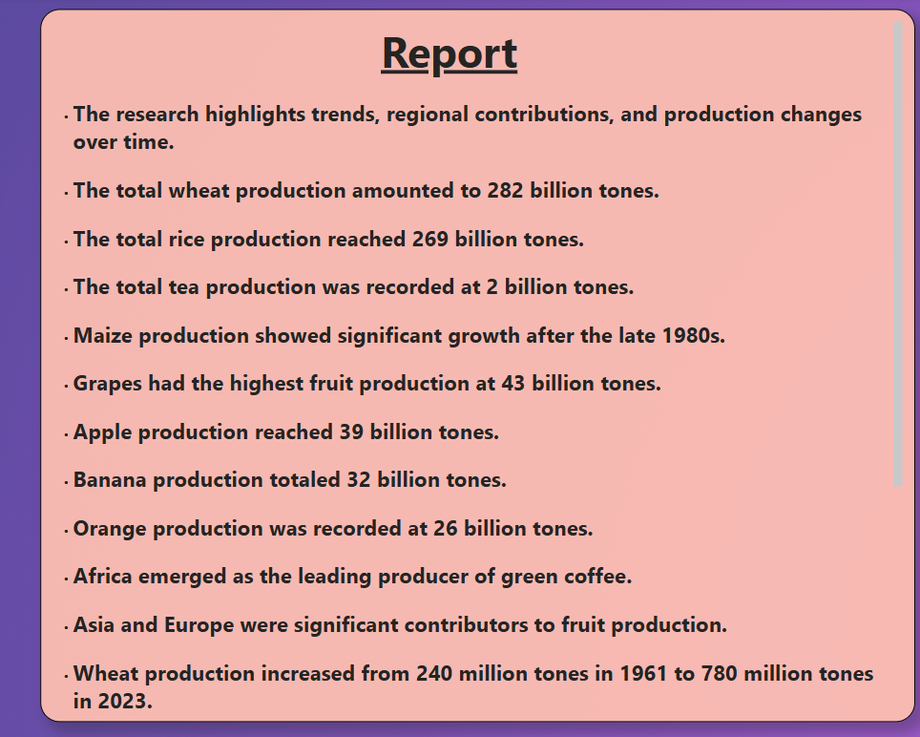

**Milestone 6: Performance Testing**

Performance testing is a crucial aspect of software development aimed at evaluating the speed, responsiveness, stability, and scalability of an application under various workload conditions. It involves simulating real-world usage scenarios to assess how the system behaves and performs under stress, peak loads, or normal conditions.

**Activity 1: Utilization of Data Filters**

The utilization of data filters plays a pivotal role in streamlining information processing and analysis across various domains. By selectively extracting or excluding specific data points based on predefined criteria, filters enable efficient data management and enhance decision-making processes.

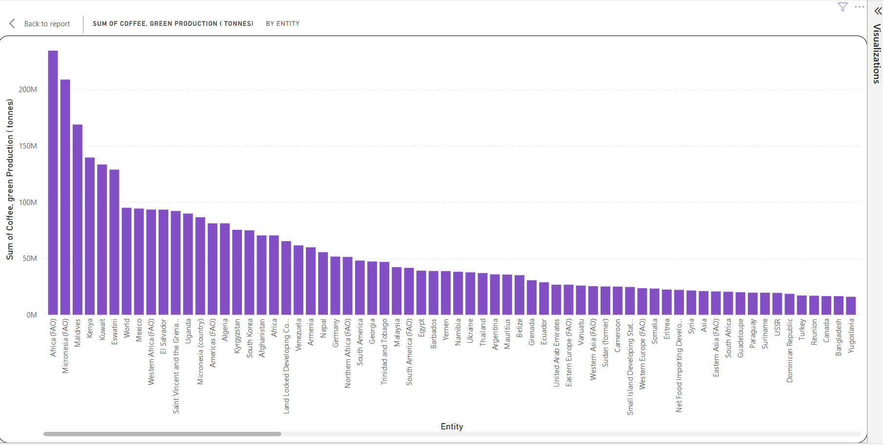

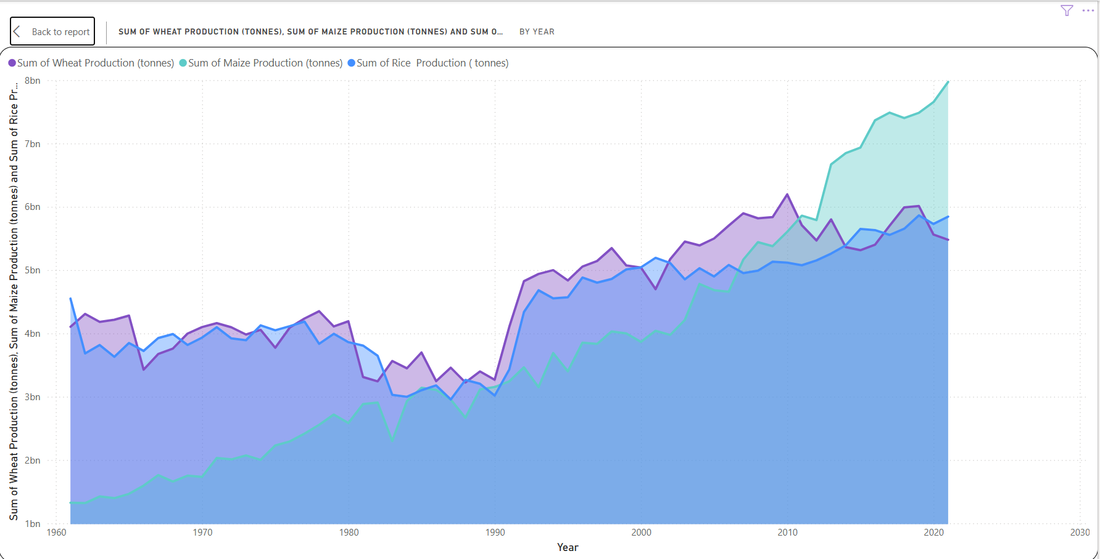

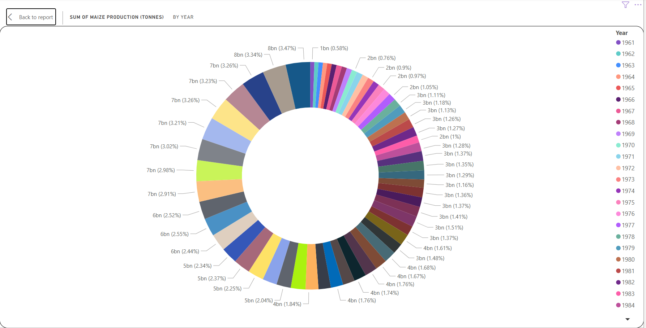

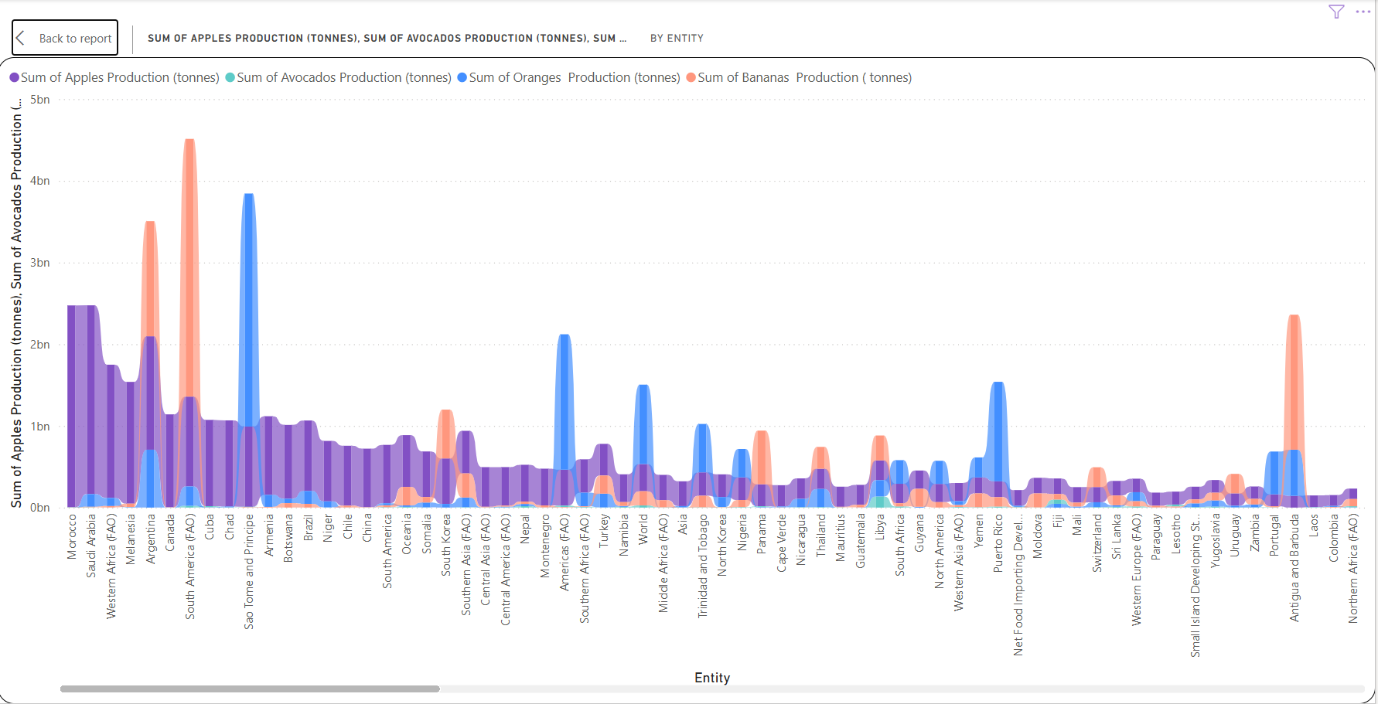

**Activity 2: Number of visualizations/graphs.**

1. **Sum Of Rice Production**
2. **Sum Of Wheat Production**
3. **Sum Of Tea Production**
4. **Sum of Coffee, green Production by Entity**
5. **Sum of Wheat Production, Sum of Maize Production, and Sum of Rice Production by Year**
6. **Sum of Apples Production, Sum of Avocados Production, Sum of Oranges Production, and Sum of Bananas Production by Entity**
7. **Sum of Maize Production (tonnes) by Year**
8. **Sum of Grapes Production (tonnes), Sum of Apples Production (tonnes), Sum of Bananas Production ( tonnes) and Sum of Oranges Production (tonnes)**

**Milestone 7: Project Demonstration & Documentation**

Below mentioned deliverables to be submitted along with other deliverables

**Activity 1:- Record explanation Video for project end to end solution**

Creating a record explanation video for a project's end-to-end solution is crucial for ensuring clarity and transparency in its implementation. This video serves as a comprehensive guide, detailing every aspect of the project from inception to completion.

**Activity 2:- Project Documentation-Step by step project development procedure**

Create document as per the template provided